WHAT WE TALK ABOUT WHEN WE TALK ABOUT POVERTY

By Cathie Jo Martin (Boston University)
& Tom Chevalier (Harvard Center for European Studies)

Paper presented at the annual meeting of the American Political Science Association
Boston, MA, August 30 – September 2, 2018
INTRODUCTION
In March 2006, French youth took to the streets to protest a “flexicurity” model of labor regulation that would allow employers easily to lay-off and to pay sub-minimum wages to young workers. French citizens rejected measures that could potentially weaken labor market projections for core workers, and preferred to use charity and passive benefits for marginal workers such as unemployed youth. In sharp contrast, Danes across the political spectrum readily supported their “flexicurity” model – which combined strong work requirements for the unemployed with extensive training – as a means of ensuring that all potential workers would make an economic contribution to society. In Britain, similar policies imposing work requirements on the unemployed lacked strong training programs and these were criticized as punitive, residual programs that did little for excluded workers. These contemporary welfare state differences have historical antecedents. Early English and Danish poor laws both banned begging; however, Denmark made local governments responsible for providing employment to the poor. France viewed indigents as worthy of Christian charity, yet government did little to help the poor.
This paper seeks to understand why countries develop different welfare state regimes; specifically, we investigate how cross-national distinctions in historical anti-poverty programs are associated with differences in cultural conceptions of poverty appearing in literature. Crucial choices in social policymaking are anchored by two cultural constructions of poverty: whether the primary target for social provision is society or the individual, and whether the appropriate agent for social intervention is the state or non-state institutions such as the church. In each era of social policy development, policymakers in Britain, Denmark and France are inspired by similar new ideas about poverty and struggle to address common economic, political and social transformations. Yet their culturally-informed views of the relationship between individual versus society and state versus non-state groups guide them toward distinctive choices in social protections that anticipate and add up to contemporary welfare regimes.
Cultural arguments are difficult to demonstrate empirically; therefore, we employ the cultural artifact of literature to grasp associations among culture and social policy development (Griswold 1987). We suggest that fiction writers and their cultural narratives about e.g. poverty, individuals, society, state and church are associated with policy outcomes in several ways. Groups of writers put neglected issues on the public agenda and their narratives influence the cognitive frames of social problems. Fictional works and other cultural artifacts make powerful emotional appeals that elevate our concerns about social problems (Keen 1996; Guy 1996, 11; Childers 2001; Poovey 1995; Johnson 2001; Dzelzainis 2012; Wedeen 2002; Lamont 2000; Swidler 1986; Weerssen 2004; McNamara 2015). Cognitive constructions of and emotional appeals about poverty influence the preferences of other actors with more direct involvement in political processes. Authors may themselves be participants in policy struggles. In all of these activities, the involvement of activist writers and cultural narratives is not deterministic, as historically-contingent factors contribute to political struggles and policy outcomes.
Yet we also observe that authors in different countries draw upon diverse cultural symbols and resources from their national literary traditions in developing images of poverty. Fiction writers as purveyors of cultural artifacts rework symbols, values and narratives to meet shifting economic and social challenges. Literary canons are constantly evolving and great authors make crucial contributions that set new directions in fiction; yet, even the most creative of writers refer to the cultural touchstones of the past. Thus we also expect to find significant cross-national cultural differences in literary narratives about poverty and anticipate that these will be associated with distinctions in welfare state regimes.
We hypothesize that if culture matters to welfare state development, cross-national distinctions should be apparent in the language about poverty. Specifically, we should observe cross-national differences in the cultural depictions of the agents (state versus private/church) and targets (society versus individual). Countries seeking social benefits to strengthen society should also be more likely to portray fighting poverty in terms of skills and social investment. Countries developing social benefits primarily to address individual needs are more likely to make reference to the suffering of families (women and children) and to associate poverty with charitable giving.
To explore the admittedly complex relationship between literature and public policy, we offer quantitative textual analyses of corpora of British, Danish and French fictional works and qualitative case studies of writers’ involvement with welfare state development. Our quantitative analyses use computational linguistic techniques in Python (word frequencies and unsupervised topic modeling) to analyze cross-national differences in the frequency of words associated with society, state, church, individual, feelings (associated with individualism), family, skills, and charity in snippets of text surrounding poverty words. Our data are drawn from corpora of 500 to 570 major fictional works (drawn from expert lists) in Britain, Denmark and France.
We supplement our quantitative analyses with qualitative case studies investigating how literary works and authors contribute to specific policy debates. We present literary depictions of poverty in advance of the enlightenment-era reforms of the late 1700s, the mid-nineteenth-century liberal reforms, and the social insurance innovations around 1900. We also discuss briefly the involvement of authors and policymakers in these political struggles.
The paper contributes to our understanding of welfare state development and fills some gaps. Much research on welfare states has focused on the modern era (but see Heidenheimer and Heclo 1990; de Swaan 1988), yet we identify salient distinctions in poor support dating back to at least the eighteenth-century and suggest that these early experiments establish path dependencies for modern welfare states. With our exploration of cultural differences in depictions of poverty, we shed light on reasons for early variations in poor support that predate the usual suspects in stories of social policy development: party systems, unions and employers’ associations. Authors are neglected actors in policy debate and we fill this gap.
The paper also contributes theoretically and empirically to the study of culture and politics. Scholars recognize the deep cultural origins of welfare states (Cox, 1992; Svallfors 1997; Petersen et. al. 2011) Yet, culture is difficult to measure and historical empirical evidence is difficult to find. Our use of literature to assess cultural influences on cross-national differences in welfare state development offers an innovative and empirically-verifiable method. Moreover, we illuminate differences between transitory ideas that periodically inspire new reforms across the world and their adaptation by individual countries as mediated by cultural touchstones. Policy-makers are inspired by reform ideas and policy diffusion to develop new approaches to poor supports, such as poor laws, parish-organized outdoor relief, indoor workhouses, social insurance programs, and citizen-based social benefits. Yet countries implement these new reform ideas in very different ways, and cultural influences shape these cross-national distinctions. Indeed, cultural depictions of poverty linked to cross-national differences in social protection systems may well have implications for the capacities of some welfare states to remain robust in the post-industrial age.
The following pages presents a typology of welfare state regimes, reveals the historical antecedents of contemporary regimes, and reviews leading theories of welfare state development. We next theorize how the cultural artifact of literature and differences in cultural narratives about 0opoverty contribute to the development of cross-national differences in welfare state regimes. We then present our quantitative and qualitative evidence. We conclude with implications for the study of culture, welfare state development, and the future of social solidarity.

CLASSIFYING WELFARE STATE REGIMES
Scholarly research on contemporary welfare states recognizes significant cross-national variation in the institutional design of social programs. Esping-Andersen (1990) distinguishes among the Social Democratic welfare regime (Denmark) with large, universal programs delivered by the state, the Christian Democratic variant (France) with social insurance programs oriented toward the male breadwinner that are often provided by non-state actors and the Liberal welfare regime (Britain) with small state programs for means-tested groups supplemented by market-based, private benefits (see also Titmuss 1976). Bonoli and Palier (2007) further distinguish institutional features of regimes by benefit type, beneficiary, mode of financing and administration. Following these works, we consolidate the institutional design of regime types (and their associated policy instruments) into two dimensions: agency, or who provides anti-poverty interventions, and target group, or who receives the benefits.
The question of agency reflects the relative importance of state, non-state institutions (church or unions) and individuals in administering social support (Evers 1990). In the first instance (found in Denmark and Britain), many benefits are administered by the state as “Beveridge,” citizen-based, public programs and funded by general revenue; however, Denmark has much larger public programs because Britain leaves much to market-based private initiatives. In the second instance (found in France), many benefits are administered as “Bismarck” social insurance programs by non-state agents (such as unions and historically the church and families. These delivery forms influence whether programs protect only the male breadwinner or also non-working women and children (Lewis 1992; Orloff 1993; Chevalier 2016; Morgan 2006).
The target group for social support concerns whether programs serve the entire society with universal programs or individual groups such as residual populations (who are defined by means-testing). Because universal programs spend more to cover more people, the target of social support is closely associated with the generosity of welfare states (Wilensky 1975), levels of redistribution and poverty reduction (Scruggs 2008). Social programs serving a universal population are also more likely to include growth-enhancing policies such as social investments in skills and to rely on active labor market policies. Programs targeted on residual groups with means-testing are more likely to offer passive benefits (Estevez-Abe, Iversen, and Soskice 2001). Table One summarizes distinctions among regimes in place by the twentieth-century.
Scholars often locate the origins of the welfare state in the late nineteenth-century, when private, voluntary insurance systems evolved into state social insurance programs with expanded social rights (Pierson 1998, 103). Yet, systems of social protection developed long before social insurance systems and diverged markedly on issues of public responsibility, attitudes toward almsgiving, role of private charity, rights to social assistance, balance between indoor and outdoor relief, and treatment of child labor. Britain and Denmark enacted earlier laws giving state the authority to regulate poverty and demonstrated greater intolerance toward begging than France, where the Catholic Church administered benefits. Denmark developed earlier active social interventions, responsibility of local governments to provide jobs and social rights; whereas Britain and France relied more on private charity. See Table Two.

THEORIES OF WELFARE STATE DEVELOPMENT
Significant cross-national variations in social provision before the twentieth-century – and even before industrialization, class and representative democracy – prompt us to reconsider the leading theories of welfare state development. One theory posits that social development responds to processes of industrialization and the “power resources” of labor to gain advantage in the cleavage between labor and capital. Capitalist production produces greater social risks (Briggs 1961, 228-9; Rimlinger 1971 and Wilensky 1975) and commodification of labor, as workers must sell their work effort in markets; welfare states permit “decommmodification” (Esping-Andersen 1990; Polanyi 1944). Strong trade unions and left parties enable workers to obtain a larger welfare state (Korpi, Stephens, Hicks 1999). Peasants in alliance with workers may also drive early social protections to cover social risks, e.g., in the Nordic countries (Baldwin 1990; Esping-Andersen, 1990).
Another explanation underscores the role of representative institutions permitting economic and political coordination in shaping the actors’ preferences and conflicts (Flora and Heidenheimer 1981, 47; McDonagh 2015). Proportional electoral systems make the right more vulnerable to potential coalitions of farmers and labor and more willing to enter into cross-class alliances (Cusack, Iversen, and Soskice 2010). Macrocorporatist industrial relations systems give social partners the capacities to negotiate consensual, enduring social pacts and larger welfare states (Martin and Swank 2004, 2012).
Yet another theory investigates the role of religion and church/state struggles in the “national revolution” stage of state-building (Lipset and Rokkan 1967). Religion is important to welfare state development in both in the agency of church leaders and in the doctrinal differences in religious sects (Van Kersbergen and Manow 2009). Religious agents promoted welfare state development with cross-class coalitions built by Christian Democratic parties (van Kersbergen and Manow 2009). In Scandinavia, Lutheran parishes were the earliest form of local government (Knudsen and Rothstein). Religious agents worked against public social provision in France, when the Catholic Church resisted the intrusion of the state into its social affairs (Manow and Palier 2009). The ideology of Protestant sects also shapes welfare policy development, in that Calvinist commitments to work are stronger than Lutheran commitments and this serves to limit social reforms in Anglo countries (Manow 2004; Rice 2013; see also McClendon and Riedl 2018).
These important theories undoubtedly contribute much to our grasp of welfare state development, yet they cannot account for all variation. Although policymakers respond to broad economic (industrialization), social (class differentiation) and political (democratization) changes, they make different choices about the level and form of social intervention. The explanations tend to fit countries unevenly and each nation favors its own welfare origin myth. For Britain, scholars emphasize the early industrialization that sets off a “great transformation,” making social protection subservient to markets (Polanyi 1944). In Denmark, the story goes that workers and farmers join forces to push a social democratic agenda of citizenship-based, social rights. In France, the failure of Protestant reformation enables continuing church control of social provision until the 1880s. Religious differences are undoubtedly crucial to the question of agency because the state’s power to seize power from the Catholic Church influences whether control over social provision is vested in church or state. Yet, the impacts of religious doctrine on welfare state development are less clear: the Nordic and Anglo countries both had state churches (Anglican and traditional Lutheranism) challenged by strong dissenting, evangelical sects. Compared to Britain, the Danish church more easily incorporated Dissenting views such as the Hernehutter into the church, and evangelical sects in Scandinavia supported social protections (Grell 1995, 10).

CULTURE AND WELFARE STATE DEVELOPMENT
Another group of scholars explores how national culture, ideas and values shape individual behaviors, political participation and policy outcomes (Weber; Geertz, 1973; Almond et Verba, 1963). Although culture has been characterized as something of a “missing variable” in welfare state studies (Baldock 1999), some scholars have crucially demonstrated the impact of ideas and values on social programs. Petersen et. al. (2011, 39) view the formation of collective identities as central to Danish welfare state development. Cox (1992) draws attention to the deep cultural logics that inform alternative systems of social delivery (See also Lin 2005; Castles 1993). Conceptions of the good society differ across social democratic, Christian Democratic and liberal welfare regimes (Oorschot, Opielka, and Pfau-Effinger 2008). Shifting ideas and values shape comparative political economies (Hall 1993; Hay 2001; Muller 2000; Schmidt 2008).
These national cultural arguments may be difficult to demonstrate empirically and overly deterministic; therefore, a recent generation of scholars, particularly in cultural sociology, use less-essentialist methods to explore how empirically-testable cultural artifacts influence individuals’ views of social issues (Griswold 1987). They begin with the observation that political agents draw from a “cultural toolkit” (of symbols, images and narratives) to formulate strategies, ascribe meaning to social problems, and construct “repertoires of evaluation” (Swidler 1986; Lamont and Thevenot; McNamara 2015).
Producers of cultural artifacts, such as fiction writers, have influence on both the “cultural toolkit” and the political agents. Writers construct stories that both resonate with and rework cultural tools when they write about new social problems (Poovey 1995; Guy 1996, 71; Milner 2005). First, fiction writers’ narratives frame cognitive perceptions of problems such as poverty and even help to put neglected issues on the agenda. One cannot point to a single cultural perspective because domains – economic versus social – have contradictory logics; indeed, groups compete to assert their own logic in the formation of national identities (Poovey 1995, 15. The Victorian social-problem novels helped to define poverty and the suffering of working class children in a culturally-specific way (Guy 1996; Poovey 1995; Carney; Childers 2001; Johnson 2001; Dzelzainis 2012). In the late eighteenth-century, literature was a crucial medium for intellectuals to debate issues, to shape public consciousness, and to influence rulers in pre-democratic regimes (Keen 1999, 33).
Second, while many sources of information (journalism, scientific work, etc) contribute to the framing of issues, fiction is particularly powerful in making emotional appeals to stimulate action on social problems. Fictional narratives may build (or diminish) the emotional commitment to helping marginal people and increase (or decrease) support for specific policy interventions. Uncle Tom’s Cabin famously inspired revolt against slavery (Swidler 1986; Lamont 2000; Weerssen 2004.) Literacy rates influenced citizen rebellion during the French Revolution, and pre-Communist literacy rates predicted post-Communist democratic institutions (Markoff 1986; Darden and Grzymala-Busse 2006.)
Fictional narratives’ influences on cognitive perceptions and emotional responses work to influence public policy by shaping the preferences of voter and actors in political processes. With their depictions of villains and attribution of blame, narratives influence the articulation of economic, religious and ethnic cleavages, and the preferences of employers, workers, peasants, clergy and party strategists. In this way, cultural artifacts are crucial to the context in which causal mechanisms take place, even when authors are not the direct decision makers or leading political agents. The context-conditionality of causal mechanisms is important because context mediates the mechanisms by which a cause has an effect (Falleti and Lynch 2009). Context is particularly important under conditions of multicausality, context-conditionality, and endogeneity (Denk and Lehtinen 2014; Franzese 2009).
Third, authors are also sometimes direct agents in policymaking. As I show elsewhere, writers were extremely active in Danish and British education movements. Many were themselves teachers or educational inspectors; for example, Matthew Arnold wielded enormous influence in British education debates. Authors such as John Stuart Mill and NHS Grundtvig also served in legislative bodies (Martin 2018). Many writers of the social reform novels of the nineteenth-century were also well-known political activists, who sought to draw attention to the dismal conditions of the working class (Carney 2017). Nineteenth-century Parliament was perceived as inadequate to cope with English conditions and novelists such as Dickens, Gaskell, Disraeli and Eliot used their work to influence political debate (Guy 1996, 11).
It is difficult to claim a definitive causal relationship about the influence of authors on policy outcomes by pointing to writers’ impacts on cognitive perceptions on problems, their emotional appeals to stimulate action or even their engagement as direct political activists. The role of each author varies enormously; writers have diverse perspectives; and authors join other political actors in coalitions for political struggle. In addition, because processes of political engagement often are dynamic and non-deterministic, historically-contingent factors may determine a policy reform’s fate.
Yet we may observe broad associations between cross-national differences in large bodies of literature and cross-national differences in policy outcomes. Granted, canons of national literature are constantly evolving and great authors make crucial contributions to new directions in fiction; therefore, literature does not merely reflect culture. Moreover, cultural constructs evolve over time; thus “the body politic” becomes the “social body” in Britain (Poovey 1995, 7). But cultural constructs such as “repertoires of evaluation” (which influence our assessment of what is worthwhile) are unevenly distributed across countries and citizens of a given country are more likely to access some repertoires of evaluation than others (Lamont and Thevenot 2000, 5-6; see also Berezin 2000.) Cultural symbols, images and narratives are also unevenly distributed across countries; authors work with the cultural resources of their national literary traditions in constructing their narratives; and even the most original writers draw upon the cultural touchstones of the past (McNamara 2015).
Our research goal is to empirically evaluate differences in the cultural narratives of countries’ literary canons and to explore the association between cross-national variations in literature and in welfare state development. If cultural artifacts of literature are associated with cross-national differences in welfare state development, then we theorize that countries will have different cultural conceptions of poverty, the legitimate agents for social provision and the appropriate beneficiaries of welfare supports. We posit that one cultural dimension associated with choices in welfare state development comprises views of the state and its legitimacy in developing social protection. Countries that view the state as the proper agent for social protection are more likely to develop Beveridge systems; whereas, countries that view non-state actors such as the church as the more appropriate agent are more likely to develop Bismarckian systems. This dimension also influences choices about the appropriate tools for social intervention.
Cultural depictions of state authority are undoubtedly influenced by countries’ historical battles between church and state. In Britain and Denmark, the state wrested power away from the Catholic Church during the Protestant Reformation; whereas the Protestant reformation failed in France and the Catholic Church continued to challenge state authority. The “state” dimension is also influenced by the doctrinal beliefs of religious sects. Protestant sects historically put a higher value on work than did Catholicism: Luther stressed work to overcome poverty and advocated for prohibitions on begging; whereas the French Catholic Church opposed limiting begging due to the moral duty of Christians to help poor (Kahl 2005).
A second cultural “society” dimension concerns the relationship between the individual and society, and this dimension should influence choices of the appropriate target group for social protection. Some countries have a strong conception of society as an organic entity that supersedes the individual (Hegel), whereas other countries view individuals as autonomous beings who enter into a “social contract” to construct a larger society (Locke). In countries with a strong conception of society, strengthening and protecting society rather than addressing individual need may be the central motivation for welfare state development. Countries that view social protections as a means for bolstering society are more likely to create universal programs with high levels of social spending to benefit society as a whole and to develop social investment policies that aid in skills development and economic growth. Thus, although Lutheranism and Calvinism both espouse work effort, collectivist Denmark should endorse work for the benefit of society more than individualistic Britain.
In contrast, countries that design social interventions predominantly to protect individual groups, such as families and children, are more likely to develop means-tested programs with lower levels of social spending. Their object is to offer support to vulnerable groups, to raise individuals’ income to a minimally-acceptable level, and possibly to redistribute income so that every individual from a new generation has a similar opportunity for self-development. Social interventions are also more likely to be associated with charitable acts that benefit those in need. The two dimensions of cultural influences on welfare states appear in Table Three.
If we are correct that literary depictions of poverty are associated with characteristics of welfare state regimes, we expect to find specific types of language in passages about poverty and significant cross-national variations in the language of poverty. First, on the state dimension, we expect to find countries with strong states to have high levels of references to words associated with “government.”
Second, we should find countries with weak states and strong non-state actors such as the church to have high levels of reference to words associated with “religion” and “charity.”
Third, on the society dimension, we should find countries with strong societies to have high levels of references to words associated with “society” and “skills.”
Finally, we should find countries with weak societies and strong individualism to have high levels of references to words associated with “individualism,” “feelings,” “families,” and again “charity,” because charity is designed to address individual rather than societal need.
To summarize, we expect to find historically high frequencies of words associated with the concepts of “state,” “society,” and “skills” for Denmark, which now has a social democratic regime (with state services, high spending levels, universal benefits, and active social investment policies). We expect to find historically high word frequencies on “state,” “individual,” “feelings,” “families” and “charity” for Britain with its contemporary liberal welfare state (state programs supplemented by private, market-based benefits, low spending levels, means-tested benefits and private charitable contributions). We expect to find high word frequencies on “church,” “individualism,” “families,” and “charity” for Christian Democratic France (with many non-state programs, low public social spending, and social insurance benefits supplemented by private charitable contributions). See Table Three.
QUANTITATIVE AND QUALITATIVE METHODS
In the following sections, we use two methods to substantiate our claims. First, our quantitative analysis uses computational linguistic and machine learning techniques (in Python) to systematically test observable differences in corpora of British, Danish and French novels, poems and plays between 1700 and 1920 (after which copyright laws limit access). If distinctive literary depictions are associated with policy choices, then we expect to find temporal and cross-national variations in the cultural scripts of large corpora of national literature that correspond to our predicted differences in evolution of welfare regimes. We construct snippets of fifty-word texts around poverty words, stem the corpora and take out stop words. We then calculate temporal and cross-national variations in word frequencies referencing state, society, individualism, feelings, church, family, skills and charity. The use of supervised learning methods calculating word frequencies is appropriate because our object is not to assess how an individual document fits into a corpus, but rather to assess cross-national and temporal differences among works that are presorted by country, language and time (Hopkins and King, 2010; Laver, Benoit and Garry, 2003). As a check on our analysis of word frequencies, we also utilize (and report separately) LDA unsupervised topic modeling to investigate whether topics in the snippets mirror the findings of the word frequencies.
The major concepts of state, society, etc. are derived from our theoretical discussion, but we must also make choices about specific words to be included in each concept. We initially generated lists of words for each category by identifying the top 200 words in major novels using the HathiTrust word cloud software and coding these words into appropriate groups. We then added synonyms derived from online searches. We carefully avoided words with multiple meanings such as “society,” which in English means being in the company of upper-class people (e.g. high society), and the community of people living in a country with shared customs, laws etc. “Society” used in eighteenth- and early nineteenth-century British literature almost always has the former meaning, which has little to do with the concept that we wish to understand; whereas by the end of the century, the latter usage takes hold. Therefore, we use the term “social” instead. We should also note that political terminology for a concept often changes over time; for example, “bienfaisance” and “charité” refer to the same broad concept and may both be translated as “charity”; however, they are used during different historical periods, as the role of the state evolved and the publicly-provided “bienfaisance” came to be used more than “charité.” We try to control for the problem of changing terminology by including relevant terms from all periods under investigation and in some cases by including the changing spelling of words (e.g. Dannemark and Danmark; England and Britain). We list words associated with each concept in the appendix.
We choose Britain, Denmark and France because we wish to include a Liberal, Social Democratic and Christian Democratic welfare regime. In selecting works, the Danish corpus of 521 works is drawn from the Archive of Danish Literature and from online lists of Danish authors. The corpus of 562 British works is constructed from multiple online lists of authors and fiction from the eighteenth, nineteenth and early twentieth-centuries. The corpus of French works is also constructed from multiple online lists of authors from the eighteenth, nineteenth and early twentieth-centuries. Full text files of all British, most French and some Danish works are provided by HathiTrust. Because available full-text files are often not first editions, we alter manually the dates of works to reflect their initial publication. Timing of publication is crucial for establishing the sequential relationship between cultural artifacts and reform moments.
Second, we supplement our quantitative findings with brief case studies of historical welfare initiatives and presentation of fictional representations of poverty in advance of crucial reform eras. We show that similar new ideas about poverty shape national responses at critical junctures; yet the realization of these ideas take somewhat different forms across the countries. For each period, we review the challenges facing nations and the reform initiatives undertaken by each country. We explore how authors’ depictions of poverty frame cognitive perceptions of poverty and make emotional appeals to address the issue, and mention (briefly due to space constraints) how authors sometimes join anti-poverty reform movements. We draw from the snippets of text in our quantitative analysis to investigate how authors portray poverty. The snippets are randomly selected, although not all snippets are used and in the French case, we also drew from the major novels of the period. We then reflect on how distinctive literary depictions of poverty in each country are associated with `crucial choices of social protections.
We focus on the period starting from 1700 to 1920. Usually, welfare studies focus on the period after the Second World War to underline cross-national variation in welfare provision. Yet we suggest that visible differences in welfare interventions are visible long before. We reflect on the eighteenth-century, when the enlightenment shapes social thought. We then move to the period of political, economic and social liberalism during the early to middle nineteenth-century grows, and conclude with the expansion of social insurance around the beginning of the twentieth-century.

QUANTITATIVE FINDINGS
Analyses of the British and Danish corpora using machine learning techniques show significant and largely predicted differences. Chart 1 presents a comparison of the appearance of poverty words in the corpora of British, Danish and French literature. Poverty is more widely discussed in Britain and Denmark than in France before 1800 and this is consistent with the more extensive political measures taken in Britain and Denmark.
Chart 2 shows that Denmark, followed by Britain, have much higher frequencies of words associated with the state than France. Britain’s references to the state are lower than Denmark’s and this seems consistent with the higher emphasis on private social initiatives in the British welfare state.
Chart 3 confirms our predictions that the social democratic welfare regime of Denmark has higher frequencies of society words than either Britain or France, where protecting individuals is a more salient motivation for social policy development than building a robust society.
Chart 4 shows that, as expected, frequencies of words associated with skills and competencies are much higher in Denmark than in Britain or France.
Chart 5 confirms our predictions that individual words are higher in Britain and France than in Denmark. Chart 6 shows that feeling words (an alternate measure of individualism) are more frequent in Britain than in Denmark. Except for the first period, feeling words are more frequent in France than Denmark. This gives credence to our hypothesis that Britain is a very individualistic society.
Chart 7 shows that charity words are significantly more frequent in British and French snippets than in Danish ones (where these are non-existent in some periods.) Chart 8 confirms that family words are significantly more frequent in British and French snippets than in Danish ones, as expected.
Chart 9 presents findings about the frequency of religion words that hint at the complexity of doctrinal arguments. Although France has higher frequencies of religion than Britain, as predicted, Denmark has the highest frequencies of religion words. This finding is contrary to conventional wisdom on the role of church-state conflict in welfare state development. But it is entirely consistent with theories about the role of the church in bolstering society and acting as a stand-in for local government in early state development in Denmark (Knudsen). A strong church does not necessarily detract from a strong state, as is the case in France. Denmark historically did not have the same sort of church-state struggles over education and social policy found in France and Britain in the nineteenth-century.
Thus, our findings largely confirm our hypotheses. In Denmark, we found high word frequencies on the “state” and “society” dimensions long before the emergence of the contemporary social democratic welfare regime. In Britain, we found medium-high word frequencies on the “state” and high frequencies on “individualism,” “feelings,” “family,” and “charity” dimensions long before the development of the liberal welfare regime. For the Christian Democratic regime found in France we found high word frequencies on the “church” and “individualism,” “church,” “family,” and “charity” dimensions long before the development of the twentieth-century Christian Democratic regime.

CASE STUDIES: SOCIAL PROVISION IN THE AGE OF ENLIGHTENMENT
We now turn to case studies of major reform movements and the manner in which authors depict poverty in advance of these movements. Our case study observations reveal that depictions of poverty in sample snippets bolster our quantitative findings. Throughout the periods discussed below, British authors associate poverty with individual villains and victims, and pay little attention to the detriments of poverty on society. Danish authors describe poverty’s harmful impacts on society from the earliest period and by 1900 emphasize the duty of the state to help victims of structural unemployment. Church rather than state is the key actor in French stories about the impoverished; indeed, the state is often portrayed as a repressive force whereas Christian charity is a friend to the poor.
Immediately after the Protestant Reformation in Britain and Denmark, these countries enact poor laws which establish the state’s role (local government) in managing the poor, limit begging, set categories of (worthy and unworthy) poor, and create a poor tax (Flora and Heidenheimer 1998, 48). The English Poor Law of 1601 codifies regulations begun under Henry VIII (Kunze, 1971, 10-13). In the early eighteenth-century, Britain develops indoor relief or poorhouses for the infirm and develops a workhouse test in 1723 to limit admittance to these institutions (Robinson 2002, 157-8). The Danish First Care Act (Nyordning) of 1708 similarly creates poor houses for the infirm destitute, and sends reluctant able-bodied workers to prison (tugthus) to do forced labor, and not only prohibits begging but fines alms givers, because controlling beggars is viewed as necessary to protecting societal peace (Social Sikring in Den Store Dansker, Wessel Hansen, 177, Peterson et. al.). Catholic France rejects Protestantism, sustains the moral duty to help the poor with charitable alms, and does not formally distinguish between the worthy and unworthy poor. The church provides poor support, based on Christian charity, although King François the 1st prohibits vagrancy in 1534 (Geremek 1997; J. P. Gutton 1974). In 1724, the French King offers some financing for 150 general hospitals to hold beggars and vagrants, but the church largely retains control of the poor and most general hospitals remain privately administered and funded (J.-P. Gutton 1973; Castel 1995; Schwartz 1988).
Ideas of the enlightenment motivated greater tolerance for the poor and expanded outdoor poor relief. Some began to recognize anti-poverty interventions as helping to offset social unrest, associated with the enclosure movement and heightened labor mobility.
England made limited changes to the poor laws, however, and the 1601 law remained the central organizing principle for poor relief. The Relief of Poor Law in 1782 expanded outdoor relief to allow the able-bodied poor to work at home (Blaug 1963, 151). The Speenhamland system, adopted after 1795 in some English progressive regions, linked workers’ wages to the price of bread, developed some public works projects and tacitly recognized structural poverty. Yet many regions did very little to combat poverty and could not prevent the depression following the Napoleonic War (Block and Somers 2014, 127-34).
In advance of the eighteenth-century reforms, English authors sought relief from poverty but portrayed the problem in terms of individual suffering, personal responsibility, and the need for charity. Writers particularly portray the suffering of women in poverty, often at the hands of men, that heighten one’s sense of pity. Thus Daniel Defoe’s Roxana (1722) depicts a young woman or whom “a morsel of bread…ruined my soul…Poverty was my snare” (Defoe, Daniel. Roxana. 1724_550-1641). Happily, Samuel Richardson’s Pamela (1740) is “bred to be more ashamed of dishonesty than poverty” (Richardson, Samuel. Pamela. 1740_388-1169, 1179). Authors strongly urge charity, as when the member of a brilliant literary society provides a home to a blind and poor orphan, who “never tried his patience or tempered his sense of compassion” (Johnson, Samuel. History of Rasselas. 1759_186-577).
In Denmark, enlightenment-era reforms are more ambitious than in England: they articulate a stronger duty and right of the able-bodied poor to work, and a stronger duty of government to guarantee this active support (Wessel Hansen, 179). The enlightenment-inspired and important Poverty Commission of 1787 proscribed a duty of society to provide work and shelters for the unemployed, hospitals to improve health care and homes for the impoverished elderly. Localities should send talented but poor youth to upper-level schools, so that they may contribute to society. These 1802 provisional regulations for poverty (with a corresponding 1803 regulation for Copenhagen) intensify prohibitions against begging, viewed as a threat to social order, but create a poverty tax and resources for the worthy poor (Hansen 2008, Wessel Hansen).
Enlightenment-era Danish authors stress the negative impacts of poverty on society and need to discipline those who threaten the social fabric. Poverty detracts from the economic and social good and the strong state is necessary to collective well-being. Danes are drawn to the works of Johann Heinrich Gottlob von Justi and Kameralism, which encourages enlightened views toward social issues (Petersen et. al. 2011, 50-3). Ludvig Holberg (the father of Danish literature) advocates for a more enlightened welfare state in Danmarks og Norges Geistlige og verdslige Staat eller Beskrivelse (in 1729 and later 1749). Holberg makes the economic case for poverty reduction to strengthen society and the common good in urging estate owners to improve the lives of their peasants. “Whoever loves himself should act in a benevolent way toward his peasants, as there is a union between their interests. The devastation of the peasant will be the devastation of the estate” (Holberg, Værker i tolv Bind" 1720_191-216). Erik Pontoppidan develops the journal, Danmarks og Norges Oeconomiske Magazin (1757-64), to publicize the economic ideas of the enlightenment (Petersen et. al. 2011, 50-3). At the same time, writers have little patience for those – particularly misbehaving youth – who bring poverty on themselves, as when Christian Falster in Lærdoms Lystgaard makes fun of the drunken student who begs, delays beginning his life and attacks those who deny him in Latin. Yet authors also recognize a nobility for worldly poverty exchanged for heavenly salvation, as when Hans Adolph Brorson ("Samlede skrifter" 1739_61-61) links the Lord’s poverty to all good gifts.
French enlightenment-era reforms begin in 1775 with Turgot’s short-lived charity workshops (“ateliers de charité”) for incapacitated beggars and vagrants, and outdoor relief for the able-bodied poor (J. P. Gutton 1974, 175). Yet the church continues to offer outdoor relief, small hospitals, and charity offices (“bureaux de charité”) (Hudemann-Simon 1997, 19–20). During the French Revolution, a 1790 committee on indigents proposes a public outdoor relief system for the disabled poor and the obligation/right to work for the able-bodied poor. But the end of the Reign of Terror prevents implementation of these recommendations, and France reverts to a system combining religious private relief, municipally-controlled hospitals for the disabled poor, and outdoor relief (“bureaux de bienfaisance”) with some public but largely private financing. Compared to England and Denmark, social assistance system remains complex, underdeveloped and reliant to a greater extent on religious and private financing (Castel 1995, 374; Dessertine et Faure 1992; Rosanvallon 1998).
As the rural and urban poor expand during the eighteenth-century, French authors advance poverty as a crucial political issue in essays and novels (Bloch 1908). The poor are positively depicted as akin to the “noble savage” (“bon sauvage”). These innocents are neither lazy nor eager for excessive wealth and have few resources; they deserve relief that is motivated by necessity. Many of these figures of the noble savage come from another country, where life is simpler than in corrupted, eighteenth-century France. Voltaire’s famous tale Candide (1759) depicts the situation of the country called Eldorado where people are simple, work and are in peace: which is also how ends the book, when the characters are finally happy, living simply out of their work thanks to their own garden. Likewise, in Rousseau’s novels Julie ou La Nouvelle Héloïse (1761) and Emile ou De l’éducation (1762), other huge successes of the 18th century, people live a simple and better life in the countryside, far from the accumulated wealth and vice of urban life: “having always lived a uniform and simple life, I have kept in my spirit all the clarity of primitive lights. The world’s maxims hadn’t darkened them, and my poverty was moving away the temptations that dictate the sophisms of vice” (Rousseau. L’Emile 1762_23-29).
Yet as in Britain, very little attention is paid by French writers to the societal detriments of poverty and need for poor laws to create work-oriented skills. French stories stress that moral education rather than poor relief is necessary to individual salvation that keeps individuals from slipping into poverty. For example, in both Histoire de Manon Lescaut et du chevalier Desgrieux (1731) by priest Prévost and Le paysan et la paysanne pervertis (1776) by Restif de la Bretonne, young men fall subject to poverty due to corrupt lives in Paris.
Thus during the enlightenment period, writers in Britain and Denmark condemn people (especially young men) who bring charity upon themselves. Yet, British writers seek expansion of social protections out of charity and pity for abused women, whereas Danish writers urge poverty reduction to improve the economy and the collective social good. French writers are less judgmental about the poor, whom they associate with the innocent in the state of nature, yet they recognize how moral corruption can lead to poverty.

AGE OF LIBERALISM AND MID-NINETEENTH-CENTURY REFORMS
If the enlightenment marks a period of growing support for poor relief, the mid-nineteenth century is a time of both growing poverty – associated with the enclosure movement, industrialization, and urbanization – and social retrenchment, due to post-Napoleonic war decline, social upheaval, and the popularity of political and economic liberalism. Although continuing to make distinctions between the deserving and undeserving poor, all three countries scale back outdoor relief in favor of punitive workhouse model. Yet the countries diverge in that Britain implements a most punitive agenda; Denmark expands social rights even while punishing those who go into workhouses; and France continues largely to rely on private, charitable assistance.
In Britain, the industrial revolution came to be perceived as an inexorable force of progress and poverty is attributed to the disorganization and culture of poverty among the working class (Armstrong, 1986, 642-3; Harold Perkin, 1969, 270). James Kay-Shuttleworth of the Poor Law Commission sought to inspire philanthropy grounded in charity that would simultaneously sustain class distinctions and eradicate some of the worst abuses of poverty. As part of the charitable relationship, lower class individuals should develop character as to be worthy of charity (Goodlad 2001, 593-5).
The Poor Law Commission report in advance of the 1834 Poor Law Amendment Act called for a uniform, national welfare system, less generous benefits for the poor and a punitive workhouse system (Webb and Webb, The English Poor Laws, loc 359). The new poor law ended outdoor relief for able-bodied males and made indoor relief truly intolerable to reinforce that work is a better option than aid (Briggs 234; Daly 1994). Yet even while legislation scaled back support for poor workers, Parliament enacted early child labor laws with the Factory Act of 1833 and the Mines Act of 1842. Thus the reforms of the period were slightly askew: legislation ended outside support for the able-bodied but also regulated child labor.
Fiction writers are influenced by political and economic liberalism, and by the political economists of the age, who fear population growth among the poor (Robinson 2002, 155-7). Malthus argues that social aid (and particularly the detested Speenhamland system) inspires the poor to have more children and live in squalor and poverty (Fishlow 1958, 46-50; Blaug 1963, 69). By 1834, most poor are viewed as undeserving paupers (Lees 1998, 41) and working class distress becomes a social disorder resulting from the lack of education and moral integrity of the poor (Poovey 1995, 57).
Writers of the era stress themes of individualism, holding individual malfeasance responsible for poverty and worrying about poverty’s impacts on individuals; yet limited attention is paid to how poverty interacts with society. Many works link poverty to the profligate behavior of (often upper-class) men, who destroy their family fortunes. Jane Austen’s villains live beyond their means, as when Willoughby “lived at an expense to which that income could hardly be equal” (Sense and Sensibility. 1811_455-1381.) For Thackery, (Vanity Fair. 1847_378_16), individual and governmental profligacy ruins both families and nations: “a selfish man will impoverish his family and often bring them to ruin, so a selfish king brings ruin on his people and often plunges them into war.” Yet poverty is also portrayed as a motivation for work, a sentiment befitting Malthusian logic. Howard writes with some irony that “a certain class of persons poverty keeps virtuous, poverty will not let a man get drunk…Poverty and idleness cannot exist together” (Outward Bound or a Merchants Adventures. 1838_245-750).
At the same time, in the wake of the punitive 1834 Poor Law, Victorian writers create a cottage industry of works depicting the agonizing conditions in the poorhouse and inspiring sentiments of pity and charity. Poverty is increasingly portrayed as victimization, although authors differentiate among classes of paupers, treating women and children with far greater sympathy than men. Charlotte Bronti writes, “if you are a Christian you ought not to consider poverty a crime” (Jane Eyre. 1847_163-526). A villain drives innocent people into the workhouse: “old people who had been in easy circumstances all their lives would have no place of repentance for their trust in him but the workhouse.” (Charles Dickens. Little Dorrit. 1855_536-217). Charles Kingsley (Yeast. 1848_290-139) blames the social missteps of the working class on poverty: “Our daughters with base born babies have wandered away in their shame. If your misses had slept, Squire, where they did, your misses might do the same.” Workhouses institutions are drawn starkly as havens for ignorance and malfeasance: the “last refuge of human woe, surrounded by those whose own miseries their ignorance or depravities had rendered callous to feeling for any but themselves” (Jones, Hannah Maria. The Forged Note. 1824_228-99.)
Victorian writers were particularly concerned about the fate of children and wrote passionately about the evils of child labor. Thus they helped to reinforce the separate treatment of some groups of the poor and explain why child labor laws protect poor children even while punitive poor laws do little to help impoverished workers. Dickens particularly resented Malthusean descriptions of the poor (Hughes, 1903, 1.) Oliver Twist was a literary response to the economistic Poor Law Reform of 1834, and A Christmas Carol constituted an attack on the report of the Second Children’s Employment Commission. Dickens celebrated the strength of his literary depictions when he told Southwood Smith, the leading author of the report, that his book would have “twenty thousands time the force” of a pamphlet on the issue (Henderson, 2000, 140-3). Nassau Senior, the 1834 Poor Law Reform’s author, complained that Scrooge responded with charity rather than with training that would allow the poor to buy their own turkeys.
Granted Victorian novelists recognized the inherent inequality in class relations. Thus Elizabeth Gaskell’s John Barton rails against the upper class who turn a blind eye to working class suffering and Gaskell explains: “At all times it is a bewildering thing to the poor weaver to see his employer removing from house to house, each one grander than the last…while all the time the weaver, who thinks he and his fellows are the real makers of this wealth, is struggling on for bread for his children, through the vicissitudes of lowered wages, short hours (Gaskell, 22). Yet Gaskell (23) goes on to dampen the force of class conflict, in writing “I know that this is not really the case…but what I wish to impress is what the workman feels.” Moreover, these writers seldom portray the poverty of the worker as a problem for society.
In Denmark, policymakers also struggle with depression after the Napoleonic wars and the optimism of the enlightenment is replaced by a turn toward liberalism, albeit of a different nature from the English version. National liberals seek greater political rights, culminating in the constitution of 1849, and economic laissez-faire, ending with the Growth Law (Næringslov) of 1857 that liberalizes trade and abolishes guilds. Liberalism in social thought appears as support for voluntarism, self-help for the working class, private initiatives instead of state intervention, and a growing interest in social insurance. Yet national conservatives hold in check liberal ideas and emphasize collective strands in society, even as they finally accepted the end of absolutism (Petersen et. al., 2011, 79-80).
The Constitutional act of 1849 officially ends outdoor support (although some continues), denies civil and political rights to inhabitants of poorhouses and creates a social right to public support for citizens who cannot support themselves (Petersen et. al. 2011, 70-2). Some such as NHS Grundtvig, a profoundly important priest and author, worry that individual rights will attenuate commitment to the social project (Pedersen 1999, 35-56). Denmark only enacted child labor regulation in 1873, forty years after the British act. The Danish interior minister’s proposed bill set off a heated debate over whether the law would be harmful to young people, because it restricted work. As an MP from the upper house put it, “I fear that this risks making many young people into sleepyheads and loafers.” Others agreed that the law might allow young people to run around the streets without any purpose and to become morally corrupt, and farmers were particularly opposed to the legislation (Arbejdermuset).
As in Britain, Danish writers during the rise of liberalism portray poverty in more personal ways, both drawing attention to individual responsibility for poverty and to the individual victims of poverty. Thus a woman in HC Andersen’s Only a Fiddler (1837-13-9) speaks harshly about her poverty when authorities take her child away. In Johanne Heiberg’s Life Resurrected in Memories, an aristocratic woman and a poor woman are both pregnant. The aristocrat asks the poor woman to breastfeed the former’s child for ample compensation, but the poor woman must give up her own child. The heartbroken mother ultimately complies because “poverty is a hard guest.”
Yet Danish narratives differ from British ones in two ways. First, while British depictions of the lower classes associate poverty with moral degradation, the Danish poor sustain a measure of self-respect. Thus in Andersen’s Only a Fiddler, a working class woman reads and asks why the poor cannot also enjoy a book. A woman and her child find happiness and solace in a tenant farmer’s poor chamber after she is abandoned by her rich husband’s family (Andersen, HC. Kun en Spillemand. 1837-13-9). One protagonist remarks, “a well-founded poverty is socially the highest possible state that one may have” (Goldschmidt.“Hjemløs En Fortælling II.”1847_114-3)
Second, Danish writers view excessive liberalism with concern and use poverty as a metaphor for the individualism that detracts from collectivism. Thus Grundtvig views the greatest poverty as “the impoverishment of the individual heart and spirit for those who have forgotten the collectivism of the golden age. The great question of the day is whether there is any way to stop this poverty of the heart and growing doubt about a golden future for Denmark” (“Udvalgte Skrifter.” 1838-122-5). Poverty as an indictment of excessive liberalism is also found in St. St. Blicher’s story about an impoverished young woman who refuses to work for the lace makers, because their working conditions resemble those of the English factory owners (Blicher, St. St. Udvalgte Vaerker. 1829_40-25).
France also faced severe economic challenges after the Napoleonic wars, yet the social reforms during the rise of liberalism took a different form from that found in Britain and Denmark. First, France was a frontrunner in developing programs to protect children. The 1811 “service des enfants assistés” and the 1838 “service des aliénés” explicitly characterized children and mentally disabled as deserving poor, entitled to relief financed by the state for the first time. A minimum age for labor (8) was established in 1841 (Dessertine et Faure 1992). Second, the state continued to take little action on poverty, leaving action to the Church, until the 1880s. During the Revolution of 1848, Republicans sought “national workshops” (“ateliers nationaux”), public assistance and a right to work. But Conservatives, Liberals, Monarchists and the Church resisted state intervention in economy and society (Renard 1986). Third, while ignoring poor relief and public assistance, Emperor Napoléon III recognized the “societies for mutual help” (“sociétés de secours mutuel”) in 1852. This innovation in social insurance created policy space for voluntary healthcare insurance, although participants remained limited in number and focused on non-elderly at risk of illness.
As in Britain, French novelists first and foremost depict poverty as a problem for the individual, and in particular, for educated, ambitious young men, rather than the working-class, who wish to escape the limits of rigid social structures. Gifted young man seek to make a name for themselves and upward social mobility; they include main Balzac’s characters such as Raphaël de Valentin in La Peau de chagrin (1831), Rastignac in Le Père Goriot (1835), or Lucien de Rumbempré in Les Illusions perdues (1843). While not extremely poor, these characters are far from wealthy, yet they are educated and eager for social recognition. Thus, the objective is the individual achievement of gifted people, equality of opportunity, and a focus on the individual rather than on society.
Other novels do depict truly poor individuals without education. Toward the beginning of the century, these characters are often cast in a very negative light. Thus, Balzac’s Vautrin, a former convict and criminal, is deeply corrupted and Balzac more broadly portrays the poor as deeply flawed and do not deserve help. Victor Hugo depicts the poor more positively. Thus Quasimodo in Notre Dame de Paris (1831) is an orphan hunchback who deserves relief, which is provided by the Church.
The state is often portrayed as a repressive rather than ameliorating force in the treatment of the poor. Telling in this regard is Victor Hugo’s bestseller Les Misérables (1862), which Hugo writes in exile after the coup d’Etat of Louis Napoleon Bonaparte in 1851. In French, the expression “les misérables” means both the poor and the despicable, and the novel frequently presents characters that are both poor and despicable, such as the Thénardier. But the novel also depicts noble poor people, such as Marius and Jean Valjean. Marius “was poor and his room was indigent. Still, while his poverty was noble, his attic was clean” (Hugo. Les misérables 1862_285-386). As in Balzac’s novels, he is the example of the educated young man who claims for upward social mobility against rigid social structures. After his jail time, Valjean seeks to become a better man and struggles to help the poor. Yet Valjean is hounded by the policeman – and representative of state authority – Javert, who seeks to repress rather than assistance the unfortunate characters in the novel (in a context of a non-democratic political regime).
Thus, in the mid-nineteenth century, British writers link poverty to the individual, and their works nurture sentiments of pity and charity. Villainous individuals bring poverty upon themselves, unfortunate individuals suffer the consequences of this villainy, yet poverty is seldom depicted as a blight on society. In Denmark, the poor may enjoy self-esteem and the greatest threat is that the poverty of spirit might detract from the collective. In France, the poor are also treated in an individualistic manner, as constraints against social mobility keep ambitious young men from achieving their full potential, and the state does little to aid those in poverty.

TURN OF TWENTIETH-CENTURY – SOCIAL INSURANCE AND SOCIAL RISK
With the worldwide, long depression from 1873 to 1893, liberal economic ideas grow increasingly out of favor and structural unemployment reinforces the perception that poverty is beyond individual control, even for able-bodied workers. The economic stresses reveal flaws in self-regulating markets and globalization has clear social risks (Briggs 1961, 232). During the decades surrounding 1900, countries develop social insurance programs that in some cases ultimately expand into universal citizenship benefits.
In Britain, the National Insurance Act of 1911, created national health insurance (the larger part of the bill) and a small but compulsory unemployment insurance scheme. Unemployment insurance remained a limited part of the strategy to combat poverty, and Britain relied instead on means-tested social assistance (Gough et al, 1997). The insurance scheme followed a Norwegian model with cost-sharing among the state, employers and employees. Politicians expected that a private, union-run scheme would develop on top of the public one; however, this failed to happen (Foerster 1912, 300-304). Moreover, scheme initially applied only to engineering, shipbuilding, and construction industries, although it gradually extended to other sectors (Matsunaga 2017). The act proposed labor exchanges, yet these remained under-developed and ill-equipped to provide real jobs for the unemployed (Shepard 1912, 232-4). The limited scope of the unemployment insurance partly reflected Lloyd George’s desire to limit the negative impacts of social reforms on finance and the City of London (Gilbert 1976, 1058-60.) Yet the act was also consistent with Britain’s history of social innovation: support met an individual minimum rather than a societal maximum; state power was mobilized to control individual malfeasance rather than to provide jobs (Harris 1992, 119).
In the latter part of the nineteenth-century, literary depictions of poverty recognize the structural risks associated with capitalism and globalization, and emphasize that poverty and unemployment are sometimes beyond one’s own control. Some poor protagonists develop a sense of injustice about their situation. Thus in The Nether World by Gissing, the protagonist “did not serve her tyrants with willingness, for their brutality filled her with a sense of injustice” (Gissing, George. The nether world. 1899_280-124.) Gissing’s Denzil Quarrier articulated a right to social support: “Why if I found myself penniless in the streets, I would make such a row that all the country should hear of it…It would be the duty of society to provide me with it and I would take good care that I was provided, whether in workhouse or gaol wouldn’t matter much.…as civilized beings we have rights, every man is justified in claiming food and shelter” (George Gissing’s Denzil Quarrier (1892_262-109).
In late 19th century Denmark, the threats of global risk, limits of the self-regulating market and inadequacies of the old forms of social protection also became increasingly apparent. Actors across the political spectrum sought a more comprehensive approach to social problems and their solutions, and this began the move toward universalism. Professionals, experts, and interest groups wished to create “the good society” and recognized social protections as a measure to stabilize worker unrest (Petersen et. al. 2011, 81-2).
The Unemployment Insurance of 1907 recognized structural unemployment and created state-subsidized unemployment funds for a universal population (also without a loss of civil rights) (Den Store Danske Gyldendal. “Danmark -- Social Sikring”). The voluntary private unemployment scheme with state subsidies replaced the extant patchwork of private and local public programs. The 1907 law passed unanimously with the support of all political parties; the Social Democrats (representing labor) and Right Party (representing employers) were particularly strong supporters, since unemployment would benefit rural agricultural workers less than urban industrial ones. Although the Social Democrats sought to vest unions with control over the insurance, the Right Party insisted that separate insurance funds be created (Nørgaard, 186-217; Levine, 1988, 93-4; “Arbejdsanvisning og Arbejdsløshedsforsikring.”). In 1913, another act created a national labor exchange, consistent with the Danish state’s historical role of guaranteeing work opportunities for citizens, and the unemployment insurance and labor exchange parts were joined together in 1921. The Danish Ghent unemployment insurance system became extensive and generous, and social assistance (for those outside of the labor market) remained a small, residual program (Lødemel 1997; Gough et al., 1997).
Danish writers at the end of the nineteenth-century increasingly portray poverty as an externally-induced affliction that erodes the human spirit. In Forskrevet (1886_94-87), Holger Drachmann writes of poverty’s effects: one is initially protected by youthful self-esteem, yet the shame of poverty makes it more difficult to wear a smiling mask over a painful grimace. In A Politician’s Story (Edvard Brandes. 1889_49-53), the protagonist lives in poverty as a student, but is more fortunate than others because he knows that this period will end.
The great socialist writer, Martin Nexø Andersen, documents the struggles of the Danish working class against structural unemployment, argues that unemployment is not due to individual culpability and challenges the state to take responsibility for the problem. In Pelle the Conqueror, protagonist Pelle and Baker Jørgen argue about unemployment. Pelle points out that the poorhouse cannot help all who need charity: it is full and unemployment numbers in the ten thousands. Baker Jørgen retorts that in their town, each master takes care of his own: “here is no need that one did not bring on oneself.” But Pelle demands a well-ordered welfare system (Pelle erobreren. 1907_401-7). When an accident leaves three children orphaned and one with a mangled hand, Pelle reflects angrily on the social order that causes children to toil in dangerous jobs (Martin Nexoe Andersen. Pelle erobreren. 1909_403-9.)
Social support gains legitimacy; thus Pelle’s father acknowledges that his thoughts about social benefits have changed. The dying father asks Pelle not to undertake anything insurmountable for his sake, but to leave it to the poor house “that I have up until now have kept myself free from, but it is a stupid pride. The poor man and the poorhouse belong together. I have come to see differently about many things in these later years.” (Martin Nexoe Andersen", Pelle erobreren. 1909_403-10.)
In France, the Third Republic was established when the Emperor lost to Bismarck’s Prussia in 1870. Anti-clerical Republicans challenged and ultimately triumphed over clerical Monarchists in the new regime, and this shifted the balance of political life between church and state (Manow and Palier, 2009). The “laicization” of social protection (Renard 1995), especially in social assistance, occurred with laws passed in 1893, 1905, and 1913 (Renard 1986, 22). An 1898 law (“Charte de la mutualité”) abolished limits on membership in mutual societies and fostered the growth of mutual associations, which formed to cover new risks such as old age and pensions.
The new system broadly offered protections against social risks with a sizable public component; however, the Church continued to deliver parallel benefits (Brodiez-Dolino 2013, Renard 1986) and various programs served the different population categories (Dessertine and Faure 1992). Republicans and Traditionalists agreed that individuals could no longer bear responsibility for their own poverty, but Republicans sought a strong role for the central state and the Traditionalists preferred delivery by Church and family. The fragmented system and public control of social welfare by municipalities constituted a compromise (Schmidt 1990; Renard 1986). In 1930, the French welfare system settled on a fragmented public assistance system and a voluntary (but restricted) Ghent unemployment insurance, that was managed by trade unions and subsidized by the state. Efforts to convert it into a larger, compulsory unemployment insurance scheme with benefits for dependents fail until 1967 (Hatzfeld 1971).
French authors of this period also stress the structural nature of poverty under conditions of expanding social protections; however, they continue to depict state intervention with some skepticism. Thus Emile Zola’s famous novel Germinal (1885) describes the difficult life of workers and miners in Northern France. Zola’s Etienne falls into poverty after losing his job and becomes first a miner and then the leader of the workers’ strike against the company. The novel reads like a manifesto to the rise of labor activism and also offers insight into how depictions of poverty have evolved. Poverty affects able-bodied individuals, not because they are lazy, but because of involuntary unemployment due to economic transformation (Sassier 1990). Yet unlike in Denmark, the working class must defend itself against the state, which violently represses the strikes in the novel (Radé 2015).
To summarize, by the early twentieth-century, all three countries had created anti-poverty programs that recognized social risk. Yet although Britain created a compulsory program and Denmark produced a voluntary one, the Danish system quickly expanded to include a much broader cross-section of the economy than the British program. France developed a voluntary Ghent unemployment insurance scheme, managed by trade unions and subsidized by the state, yet the system remained small and highly fragmented. Authors in all three countries increasingly allude to economic structural risks that transcend individual culpability and protagonists increasingly feel a legitimate right to social benefits. Yet in France, the state is depicted as oppressing the working class; whereas in Denmark, the state is viewed as a legitimate aid to workers.

CONCLUSION
Modern welfare regimes bring to mind rather different associations: thus, whereas the Nordic countries famously link anti-poverty programs to social investments, the Liberal countries have residual programs for the poor that rely a great deal on private charity (King 1995; Iversen and Stephens 2008). These differences have deep historical roots. Thus in the eighteenth-century, Britain and Denmark both created outdoor relief for the able-bodied, but Denmark also gave local governments the duty to provide work to the able-bodied. French aid to the poor largely remained under private church control, despite brief experimentation with state provision during the French Revolution. When anti-poverty measures became more punitive with the rise of liberalism in the mid-nineteenth century, the British and Danish state locked the able-bodied poor in workhouses; yet Denmark also created a new social right to aid. The church retained control in France. In the early twentieth-century, all created some social insurance for workers along with aid to the poor. Britain’s compulsory, national unemployment insurance remained experimental and limited, and means-tested social aid continued to be the major bulwark against poverty. Denmark emphasized social investment goals with an expansive voluntary Ghent unemployment insurance program and an active labor exchange, and the residual social assistance component remained small. The French state finally wrested control away from the church and implemented a national public assistance scheme; yet this remained highly fragmented and targeted on specific groups.
Scholars have shown cultural values to be linked to modern cross-national distinctions in welfare programs (Svallfors); however, pinpointing the historical contributions of culture has been more elusive. We seek to fill this gap by analyzing the cultural artifacts of British, Danish and French literature that shape people’s perceptions of poverty. Specifically, we explore whether significant cross-national differences in the treatment of poverty exist in novels. We then consider how differences in literary depictions may be associated with diverse choices in the evolution of welfare state regimes. We hypothesize that depictions of poverty vary along two dimensions (cultural conceptions of the state versus non-state institutions and of the individual’s role in society); these cross-national variations are associated with different choices in social policies. We use quantitative computational linguistic methods to analyze large corpora of literature in Britain, Denmark and France in order to evaluate cross-national differences in the language of poverty and to reflect on their association with welfare state regimes. We also explore the micro-processes underlying the quantitative findings with brief case studies that demonstrate how authors engage with political actors and policy debates.
We find distinctive differences in the corpora of our three countries. In the Danish social democratic welfare state, we find in snippets of text surrounding poverty high frequencies of words about state, society and skills/capacities dating back to 1700, long before the emergence of the social democratic welfare regime. Already by the eighteenth-century, Danish writers discuss poverty in terms of improving the economy and providing collective social goods. In Britain, the snippets reveal somewhat lower frequencies of words about the state, but high frequencies of words about individualism, feelings, families and charity. Eighteenth-century British writers are motivated by charity and pity for abused women to support poverty reduction. Advocates in Britain and Denmark would curb disruptive behaviors by able-bodied young men who bring poverty upon themselves. But in Britain, these men hurt their female relatives; in Denmark, they are a nuisance to society. In France we find high word frequencies on words associated with individualism, religion and charity long before the emergence of Christian Democratic (or Mediterranean) welfare regimes. French writers in the eighteenth-century associate the poor with the “bon savage” in the state of nature, who deserves our charity regardless of the reasons for his/her impoverishment.
These findings have ramifications for the study of welfare states. Similar economic and social challenges motivated British, Danish and French policymakers to experiment with similar new approaches to fighting poverty; however, cultural narratives about poverty mediated these national responses and created policy legacies that evolved into modern welfare state regimes (see also Berman 1998). The underlying dimensions of state and society worked to reinforce or diminish social cleavages, making cleavages along the lines of religion or class more important in some setting than in others. The cultural dimension also sheds light on how countries resolve their national and industrial revolutions and the role of social provision in these processes.
Our findings also shed light on the virtual circle of the Social Democratic welfare regime. A deep commitment to building a strong society, rather than redistribution for equality, dates back to the early 1700s and helps us to understand the modern social democratic emphasis on social investment policies.

BIBLIOGRAPHY
Almond, Gabriel Abraham, and Sidney Verba. 1963. The Civic Culture: Political Attitudes and Democracy in Five Nations. Newbury Park, Calif: SAGE Publications Inc.
Baldock, John. 1999. “Culture: The Missing Variable in Understanding Social Policy?” Social Policy & Administration 33(4): 458–473.
Baldwin, Peter. 1990. The Politics of Social Solidarity: Class Bases of the European Welfare State, 1875-1975. Cambridge: Cambridge University Press.
Berman, Sheri. 1998. The Social Democratic Moment: Ideas and Politics in the Making of Interwar Europe. Cambridge, MA: Harvard University Press.
Blaug, Mark. 1963. “The Myth of the Old Poor Law and the Making of the New.” Journal of Economic History 23 (2 June): 151-84.
Bloch, Camille. 1908. L’assistance et l’Etat En France à La Veille de La Révolution: Généralités de Paris, Rouen, Alençon, Orléans, Chalons, Soissons, Amiens, 1764-1790. Paris: A. Picard et fils.
Block, Fred and Margaret Somers. 2014. The Power of Market Fundamentalism. Cambridge: Harvard University Press.
Bonoli, Giuliano, and Bruno Palier. 2007. “When Past Reforms Open New Opportunities: Comparing Old-Age Insurance Reforms in Bismarckian Welfare Systems.” Social Policy & Administration 41(6): 555–73.
Briggs, Asa. 1961. “The Welfare State in Historical Perspective. European Journal of Sociology 2 (2 On the Welfare State): 221-258.
Brodiez-Dolino, Axelle. 2013. “Entre Social et Sanitaire : Les Politiques de Lutte Contre La Pauvreté-Précarité En France Au XX ^{e} Siècle.” Le Mouvement Social 242(1): 9–29.
Carney, Bethan. Social-Problem Novel. Oxford Biographies. DOI: 10.1093/obo/9780199799558-0011. http://www.oxfordbibliographies.com/view/document/obo-9780199799558/obo-9780199799558-0011.xml.
Castel, Robert. 1995. Les Métamorphoses de La Question Sociale: Une Chronique Du Salariat. Paris: Fayard.
Castles, Francis, Stephan Leibfried, Jane Lewis, Herbert Obinger, Christopher Pierson eds. 2010. The Oxford Handbook of the Welfare State. Oxford University Press.
Castles, Francis G., ed. 1993. Families of Nations: Patterns of Public Policy in Western Democracies. Aldershot: Dartmouth.
Chevalier, Tom. 2016. “Varieties of Youth Welfare Citizenship. Towards a Two-Dimension Typology.” Journal of European Social Policy (26): 3–19.
Childers, Joseph W. 2001. “Industrial Culture and the Victorian Novel.” In The Cambridge Companion to the Victorian Novel. Edited by Deirdre David, 77–96. Cambridge, UK: Cambridge University Press.
Cusack, Thomas, Torben Iversen, and David Soskice. 2010. “Coevolution of Capitalism and Political Representation: The Choice of Electoral Systems.” American Political Science Review 104(02): 393–403.
Cusack, Thomas R., Torben Iversen, and David Soskice. 2007. “Economic Interests and the Origins of Electoral Systems.” American Political Science Review 101(03): 373.
Daly, Mary. 1994. “A Matter of Dependency.” Sociology 28 (3 August): 779-797.
Den Store Danske Gyldendal. “Danmark -- Social Sikring.” http://denstoredanske.dk/Samfund,_jura_og_politik/Samfund/Sociale_forhold_i_verden/Danmark_-_social_sikring
Dessertine, Dominique, and Olivier Faure. 1992. “Assistance Traditionnelle, Assistance Nouvelle.” In De La Charité Médiévale à La Sécurité Sociale. Economie de La Protection Sociale Du Moyen-Age à l’époque Contemporaine, eds. André Gueslin and Pierre Guillaume. Paris: Editions Ouvrières, 139–52.
de Swaan, A. 1988. In Care of the State: Health Care, Education, and Welfare in Europe and the USA in the Modern Era. Oxford: Oxford University Press.
Dzelzainis, Ella. “Radicalism and Reform.” In The Nineteenth-Century Novel, 1820–1880. Vol. 3, of The Oxford History of the Novel in English. Edited by John Kucich and Jenny Bourne Taylor, 427–443. Oxford: Oxford University Press, 2012.
Esping-Andersen, Gosta. 1990. The Three Worlds of Welfare Capitalism. Princeton: Princeton University Press.
Estevez-Abe, Margarita, Torben Iversen, and David Soskice. 2001. “Social Protection and the Formation of Skills: A Reinterpretation of the Welfare State.” In Varieties of Capitalism, eds. Peter A. Hall and David Soskice. Oxford: Oxford University Press, 145–83.
Evers, Adalbert. 1990. “Shifts in the Welfare Mix. Introducing a New Approach for the Study of Transformations in Welfare and Social Policy.” In Shifts in Welfare Mix: Their Impact on Work, Social Services, and Welfare Policies, eds. Adalbert Evers and Helmut Wintersberger. Campus: Westview.
Ferrera, Maurizio. 1996. “The ‘Southern Model’ of Welfare in Social Europe.” Journal of European Social Policy 6(1): 17–37.
Fishlow, Albert. 1958. “T. R. Malthus and the English Poor Laws.” Social Science 33 (1 Jan): 45-51
Flora, Peter, and Arnold Joseph Heidenheimer, eds. 1981. The Development of Welfare States in Europe and America. Transaction Publishers.
Foerster, Robert F. 1912. “The British National Insurance Act,” The Quarterly Journal of Economics 26 (2 Feb.): 275-312.
Geertz, Clifford. 1973. The Interpretation Of Cultures. New York: Basic Books.
Geremek, Bronisław. 1997. La potence ou la pitié. L’Europe et les pauvres du moyen âge à nos jours. Paris: Gallimard.
Gilbert, Bentley. 1976. “David Lloyd George: Land, The Budget, and Social Reform.” The American Historical Review 81 (5 Dec.): 1058-1066
Gough, Ian et al. 1997. “Social Assistance in Oecd Countries.” Journal of European Social Policy 7(1): 17–43.
Great Britain.1834. Report of the Poor Laws Commission. http://www.econlib.org/library/YPDBooks/Reports/rptPLC.html
Grell, Ole Peter. 1995. “Introduction.” In Grell eds. The Scandinavian Reformation: From Evangelical Movement to Institutionalization of Reform. Cambridge University Press.
Griswold, Wendy. 1987. “A Methodological Framework for the Sociology of Culture.” Sociology Methodology 17: 1-35.
Gutton, Jean Pierre. 1974. La Société et Les Pauvres En Europe, XVIe-XVIIIe Siècles. Paris: Presses universitaires de France.
Gutton, Jean-Pierre. 1973. L’Etat et La Mendicité Dans La Première Moitié Du XVIIIe Siècle. Auvergne, Beaujolais, Forez, Lyonnais. Centre d’études foreziennes.
Josephine Guy. 1996. The Victorian Social-Problem Novel. London UK: MacMillan Press.
Hall, Peter A. 1993. “Policy Paradigms, Social Learning, and the State: The Case of Economic Policy-Making in Britain.” Comparative politics 25(3): 275–96.
Hansen, Peter Wessel. 2008. Den strafværdige gavmildhed: Synet på almissegivning, betleri og fattiglove i 1700-tallets Danmark. Fortid og Nutid (September): 173-197. file:///C:/Users/cjmartin/Downloads/75435-160 909-1-PB.pdf.
Harris, Jose. 1992. “Political Thought and the Welfare State 1870-1940: An Intellectual Framework for British Social Policy.” Past & Present 135 (May): 116-141.
Hatzfeld, Henri. 1971. Du Paupérisme à La Sécurité Sociale. Essai Sur Les Origines de La Sécurité Sociale En France. 1850-1940. Paris: Armand Colin.
Hay, Colin. 2001. “The ‘crisis’ of Keynesianism and the Rise of Neoliberalism in Britain: An Ideational Institutionalist Approach.” In The Rise of Neoliberalism and Institutional Analysis, eds. JL Campbell and O Pedersen. Princeton, N.J.: Princeton University Press, 193–218.
Heiberg, Peter Andreas. 1788 (English version 1799). Heckingborn, Poverty and Wealth, https://books.google.com/books?id=eSFdAAAAcAAJ&pg=PA1&lpg=PA1&dq=Heibergs,+Peter+Andreas+on+poverty&source=bl&ots=RnJ7isF9HH&sig=PP5_d_sXCJOAjWpuW6IrNOdfpNs&hl=en&sa=X&ved=0ahUKEwjviIvs6KDZAhXHrFkKHU2sCJYQ6AEITTAI#v=snippet&q=Soroe&f=false
Hudemann-Simon, Calixte. 1997. L’Etat et Les Pauvres. L’assistance et La Lutte Contre La Mendicité Dans Les Quatre Départements Rhénans, 1794-1814. Jan Thorbecke Verlag Sigmaringen.
Iversen, Torben and John Stephens. 2008. “Partisan Politics, the Welfare State, and Three Worlds of Human Capital Formation.” Comparative Political Studies 41 (4/5): 600-637.
Johnson, Patricia. Hidden Hands: Working-Class Women and Victorian Social- Problem Fiction. Athens: Ohio University Press, 2001.
Kahl, Sigrun. 2005. “The Religious Roots of Modern Poverty Policy: Catholic, Lutheran, and Reformed Protestant Traditions Compared.” European Journalf of Sociology 46(1): 91–126.
Keen, Paul. 1999. The Crisis of Literature in the 1790s. Cambridge, UK: Cambridge University Press.
King, Desmond. 1995. Actively Seeking Work? Chicago: University of Chicago Press.
Kjældgaard, Lasse Horne. 2012. “Den komplekse guldalder – kort fortalt”: Magasinet. 25, 2, s. 28-34.
Kunze, Neil. 1971. “The Origins of Modern Social Legislation: The Henrician Poor Law of 1536.” Albion: A Quarterly Journal Concerned with British Studies 3 (1 Spring): 9-20
Lamont and Thevenot. “Introduction: toward a renewed comparative cultural sociology.” 1-22.
Lees, Lynn Hollan. 1998. The Solidarities of Strangers: The English Poor Laws and the People 1601-1948. Cambridge University Press.
Lewis, Jane. 1992. “Gender and the Development of Welfare Regimes.” Journal of European Social Policy 2(3): 159–73.
Lipset, Seymour Martin, and Stein Rokkan. 1967. Party Systems and Voter Alignments: Cross-National Perspectives. Free Press.
Lødemel, Ivar. 1997. The Welfare Paradox: Income Maintenance and Personal Social Services in Norway and Britain, 1946-1966. Scandinavian University Press.
Manow, Philip. 2004. “The Good, the Bad, and the Ugly. Esping-Andersen’s Regime Typology and the Religious Roots of the Western Welfare State.”Manow, Philip, and Bruno Palier. 2009. “A Conservative Welfare State Regime without Christian Democracy? The French Etat-Providence, 1880-1960.” In Religion, Class Coalitions, and Welfare States, Cambridge: Cambridge University Press.
Martin, Cathie Jo, and Duane Swank. 2012. The Political Construction of Business Interests: Coordination, Growth, and Equality. Cambridge: Cambridge University Press.
Martin, Cathie Jo. 2018. “Imagine All the People: Literature, Society and Cross-national Variation in Education Systems.” World Politics 70 (3).
Matsunaga, Tomoari. 2017. “The Origins of Unemployment Insurance in Edwardian Britain.” Journal of Policy History 29(04): 614–39.
McClendon, Gwyneth and Rachel Beatty Riedl. 2018. “From Pews to Politics: Using Sermons to Study Religions’ Influence on Politcial Participation.”
McDonagh, Eileen. 2015. “The Monarchial Origins of the Welfare State.” Perspectives on Politics. 13 (4 Dec): 992-1016.
McNamara, Kathleen. 2015. The Politics of Everyday Europe. (Oxford University Press).
Milner, Andrew. 2005. Literature, Culture, and Society. London and New York: Routledge.
Morgan, Kimberly J. 2006. Working Mothers And the Welfare State: Religion And the Politics of Work-Family Policies in Western Europe And the United States. 1st ed. Stanford University Press.
Muller, Pierre. 2000. “L’analyse cognitive des politiques publiques : vers une sociologie politique de l’action publique.” Revue française de science politique 50(2): 189–208.
Obinger, Herbert, Stephan Leibfried, and Francis G. Castles, eds. 2005. Federalism and the Welfare State: New World and European Experiences. Cambridge: Cambridge University Press.
Oorschot, Wim van, Michael Opielka, and Birgit Pfau-Effinger, eds. 2008. Culture and Welfare State: Values and Social Policy in Comparative Perspective. Cheltenham: Edward Elgar Publishing.
Orloff, Ann Shola. 1993. “Gender and the Social Rights of Citizenship: The Comparative Analysis of Gender Relations and Welfare States.” American sociological review 58(3): 303–28.
Pedersen, Finn Stendal. 1999. “N.F.S. Grundtvig og socialpolitikken I Den grundlovgivende Rigsforsamling I foraaet 1849.” Historie/Jyske Samlinger 1: 32-58.
Petersen, Jørn Henrik, Klaus Petersen, and Niels Finn Christiansen. 2011. Dansk Velfærdshistorie: Frem mod socialhjælpsstaten. Bind 1. Perioden 1536-1898.
Pierson, Christopher. Beyond the Welfare State. 1998. Pennsylvania State University Press.
Polanyi, Karl. 1944. The Great Transformation: The Political and Economic Origins of Our Time. Boston: Beacon Press.
Poovey, Mary. 1995. Making A Social Body. Chicago: University of Chicago Press.
Radé, Christophe. 2015. “Emile Zola et Le Roman Ouvrier.” Droit Social (4): 313–25.
Renard, Didier. 1986. “L’assistance En France Au 19 Siècle : Logiques de l’intervention Publique.” International Review of Community Development (16): 9–25.
———. 1995. “Intervention de l’Etat et Genèse de La Protection Sociale En France (1880-1940).” Lien social et politiques (33): 13–26.
Rice, Deborah. 2013. “Beyond Welfare Regimes: From Empirical Typology to Conceptual Ideal Types.” Social Policy & Administration 47(1): 93–110.
Rimlinger, Gaston. 1971. Welfare policy and industrialization in Europe, America, and Russia.
Robinson, Warren. 2002. “Population Policy in Early Victorian England.” European Journal of Population 18: 153-173.
Rosanvallon, Pierre. 1998. La Nouvelle Question Sociale. Seuil.
Sassier, Philippe. 1990. Du Bon Usage Des Pauvres: Histoire d’un Thème Politique (XVIe-XXe Siècle). Paris: Fayard.
Schmidt, Vivien A. 2008. “Discursive Institutionalism: The Explanatory Power of Ideas and Discourse.” Annual Review of Political Science 11(1): 303–26.
Schmidt, Vivien A. 1990. Democratizing France. The Political and Administrative History of Decentralization, Cambridge: Cambridge University Press.
Schwartz, Robert M. 1988. Policing the Poor in Eighteenth-Century France. Chapel Hill: The University of North Carolina Press.
Scruggs, Lyle. 2008. “Social Rights, Welfare Generosity, and Inequality.” In Pablo Beramendi and Christopher Andersen eds. Democracy, Inequality, and Representation in Comparative Perspective. New York: Russell Sage Foundation.
Shepard, Walter James. 1912. “The British National Insurance Act.” The American Political Science Review 6 (2 May): 229-234.
Svallfors, Stefen. 1997. “Worlds of Welfare and Attitudes to Redistribution: A Comparison of Eight Western Nations.” European Sociological Review 13 (3 Dec): 283-304.
Swidler, Ann. 1986. “Culture in Action: Symbols and Strategies.” American Sociological Review 51 (2 April): 273-86.
Titmuss, Richard M. 1976. Essays on the Welfare State. 3rd Revised edition. Routledge.
Van Kersbergen, Kees, and Philip Manow, eds. 2009. Religion, Class Coalitions, and Welfare States. Cambridge: Cambridge University Press.
Wedeen, Lisa. 2002. “Conceptualizing Culture: Possibilities for Political Science” American Political Science Review 96 (4 December): 713-28.
Weir, Margaret, Ann Orloff and Theda Skocpol eds. 1988. The Politics of Social Policy in the United States. Chicago.
Wilensky, Harold L. 1975. The Welfare State and Equality: Structural and Ideological Roots of Public Expenditures. Berkeley: University of California Press.

APPENDIX
TABLE ONE
INSTITUTIONAL DESIGN OF WELFARE REGIMES AT THE BEGINNING OF THE TWENTIETH-CENTURY
 | Denmark | Britain | France
Welfare regime | Social Democratic | Liberal | Christian-Democratic
Agency | State (Beveridge) | State and market (Beveridge) | Unions/family  Historically church (Bismarck)
Universal Target Group: Unemployment insurance | Large universal programs.  Large Ghent system | Small universal programs.  Small, compulsory unemploy. insurance | Small universal programs.  Restrictive Ghent system
Residual Target Group: Social assistance | Small with strong activation | Large with little activation | Fragmented programs

TABLE TWO

HISTORICAL DIFFERENCES IN SOCIAL POLICY

 | Britain | Denmark | France
Before 1764 | Poor Law of 1536  parish distributes aid  Poor Law of 1601  sets up system, Parish, poor tax  Worthy v. unworthy poor  govn aid to worthy poor  Abolishes begging  Settlement Act restricts movement between parishes  Workhouse Test in 1723 to keep able from getting alms | Poor law of 1552,  Parish distributes aid.  public works for King  First Care Act of 1708  Sets up system, Parish, poor tax  worthy v. unworthy poor  govn aid to worthy poor  Abolishes begging  alms-givers also fined  able poor into workhouse | No poor laws in 16th century  Privately, independent hospitals  Primarily church support  1724 Act  No formal system, but some state financed hospitals  Begging abolished in 1672  Outdoor relief for worthy poor by church  1764: Dépôts de mendicité (unworthy poor into workhouse)
Late 18th century | Relief of Poor Law in 1782  Outdoor relief for able-bodied to work at home  Poor houses for others | Poverty Commission 1787  outdoor relief for able-bodied to work at home  Poor houses for others  Duty of local govn to provide work to job seekers  Became 1802 poverty regulations | Turgot Commission in 1774 limits on vagrants  sought state “ateliers de charité” for able-bodied,  bureaux d’aumône (outdoor relief for deserving poor)  Comité de mendicité 1790 (French Revolution) sought state supports for poor  But return to private charity  by 1815, no public poor supports
Mid-19th century | Poor Law Amendment of 1834  Ended outdoor relief  Expanded workhouses  Those in workhouses lost civil and political rights  Factory Act of 1849  Regulated child labor | Constitutional Act 1849  Ended outdoor relief (although some continued)  Expanded workhouses  Those in workhouses lost civil and political rights  But right to social support  1874 Child Labor Law  Late regulation child labor | Still no public provision, but some marginal social assistance  1811: service des enfants assistés  1838: service des aliénés  1841: regulation of child labor  private charity, church and family  In 1852 state recognizes mutualist movement
Around 1900 | National Insurance Act 1911  Unemployment insurance  Health insurance  first compulsory unemployment insurance program, but experimental and very limited | Fattigloven Act 1891  Right to basic elderly pensions  Unemployment insurance 1907 Ghent program with voluntary unemployment insurance  Unemployment insurance extensive, vast coverage | Direction de l’assistance publique 1886  Public but fragmented social assistance system: 1893 (sick), 1905 (elderly and incurable), 1913 (families in need)  1905: Ghent voluntary legislation unemployment assistance, but state program only in 1967.

TABLE THREE

POLICY DIMENSIONS AND WORDS ASSOCIATED WITH EACH

 | Agent: State  Beveridge  Tools: Regulation | Agent: Church, worker funds, or other social insurance  Bismarck
Target: Society  Instruments:  Social investments in skills  High spending  Universal programs | Social Democratic model  Denmark  Expected high word frequencies:  state, society, skills/social investments | Christian Democratic Society Model  German  Expected high word frequencies: society, skills/social investment, and religion
Target: Individuals, feelings, children, families  Instruments: Charity  Low spending  means-tested programs | Liberal model  Britain  Expected high word frequencies:  state, regulation, individual, feelings, charity, families | Catholic charity model  France  Expected high word frequencies: individual, feelings, children, charity and religion.

GRAPH ONE
FREQUENCIES OF ALL POVERTY WORDS
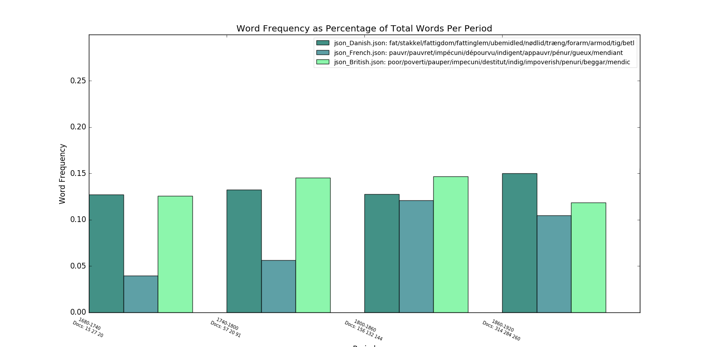

GRAPH TWO
FREQUENCIES OF STATE WORDS (WITHIN POVERTY SNIPPETS)

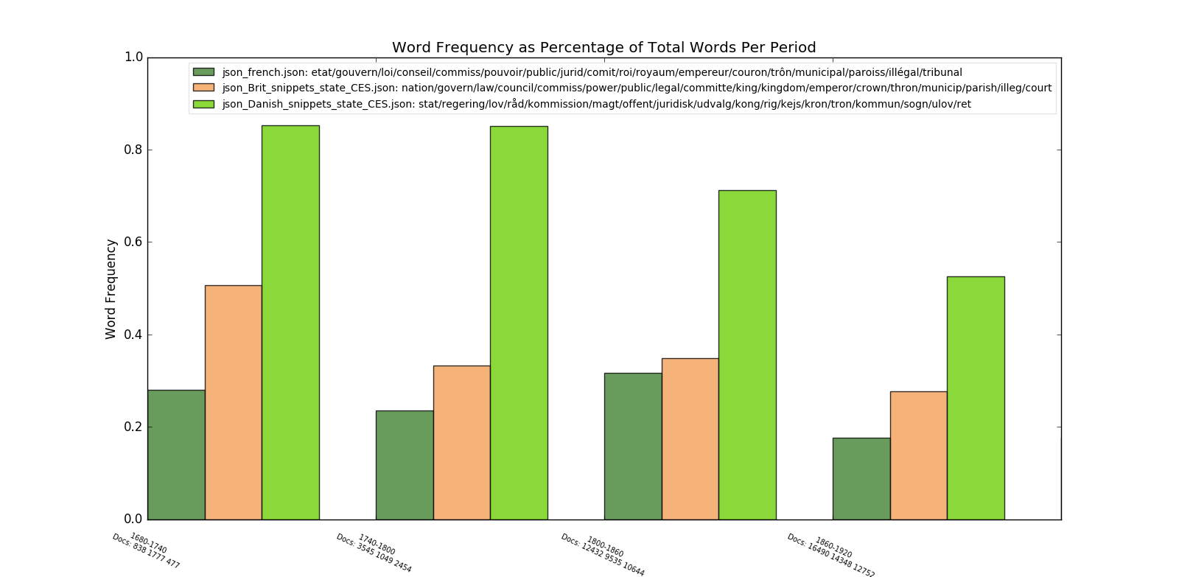

GRAPH THREE
FREQUENCIES OF SOCIETY WORDS
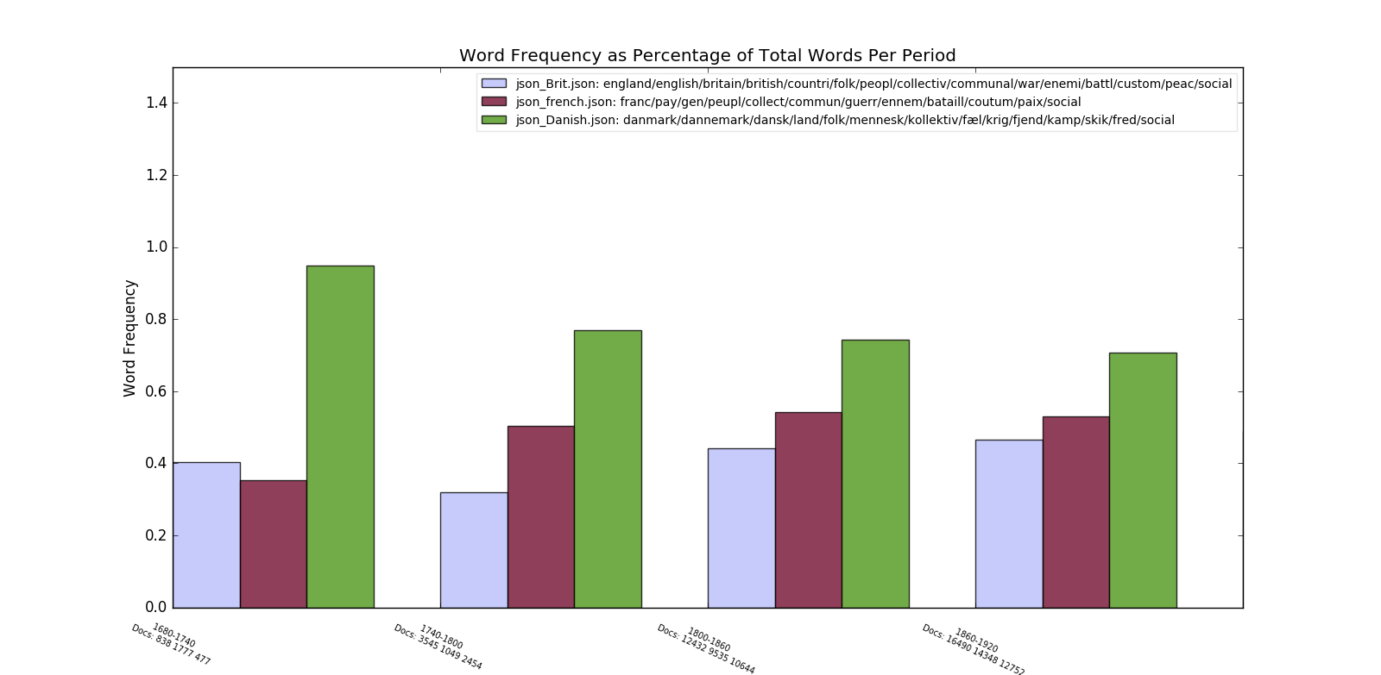

GRAPH FOUR
FREQUENCIES OF SKILLS WORDS (WITHIN POVERTY SNIPPETS)

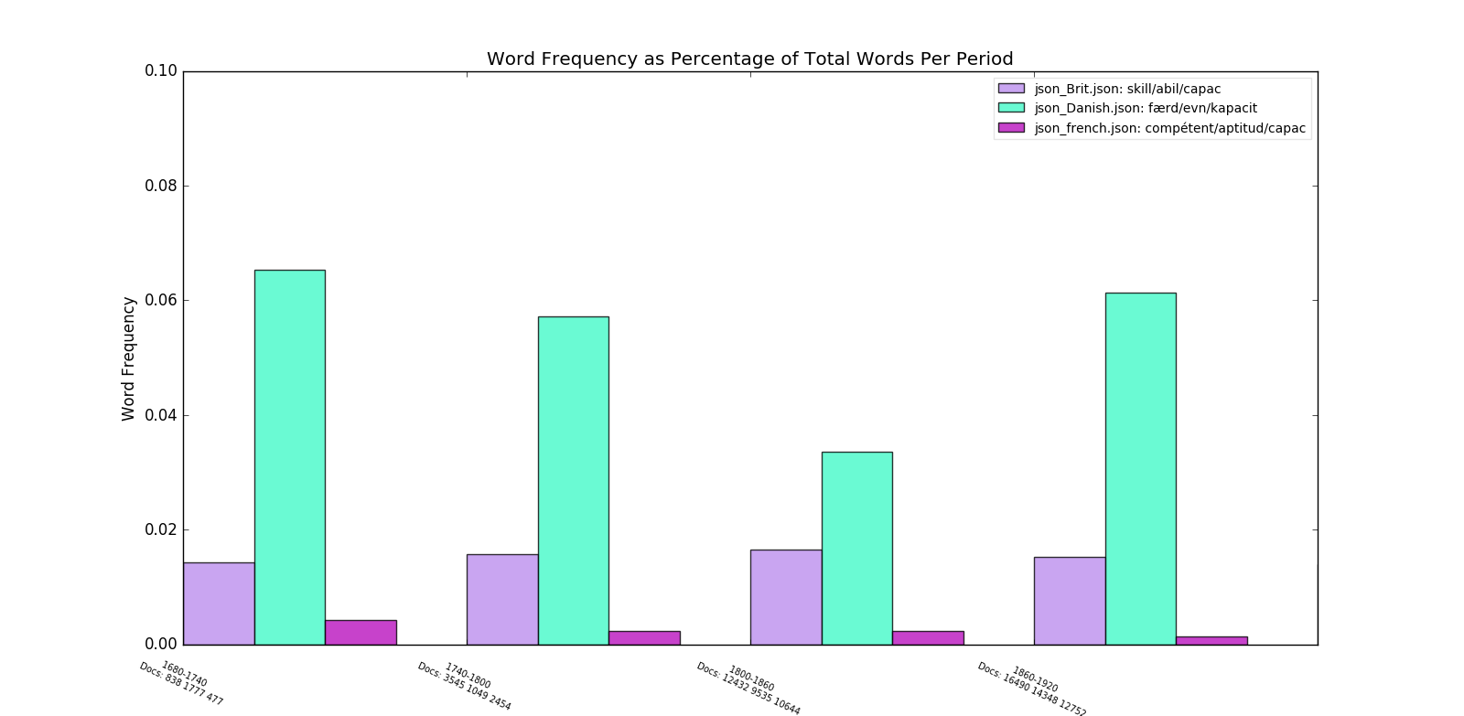

GRAPH FIVE
FREQUENCIES OF INDIVIDUALISM WORDS (WITHIN POVERTY SNIPPETS)
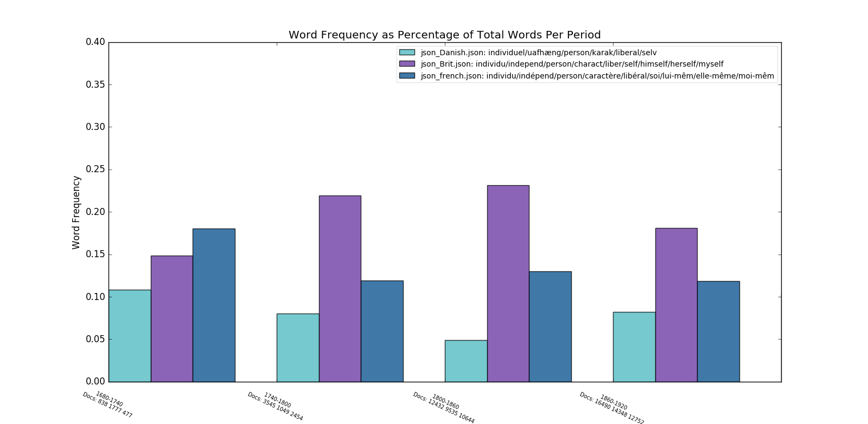

GRAPH SIX
FREQUENCIES OF FEELING WORDS (WITHIN POVERTY SNIPPETS)
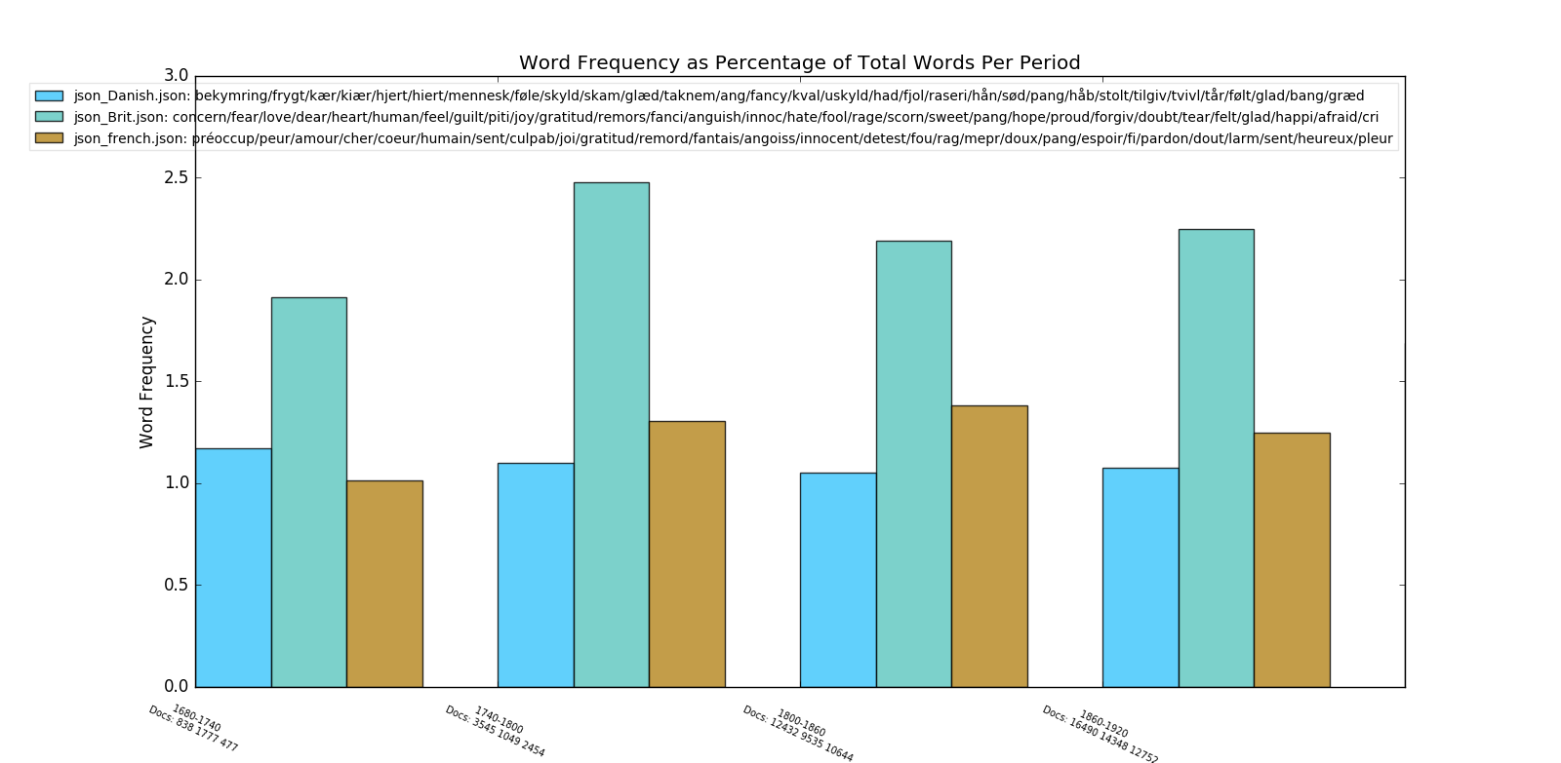

GRAPH SEVEN
FREQUENCIES OF CHARITY WORDS (WITHIN POVERTY SNIPPETS)
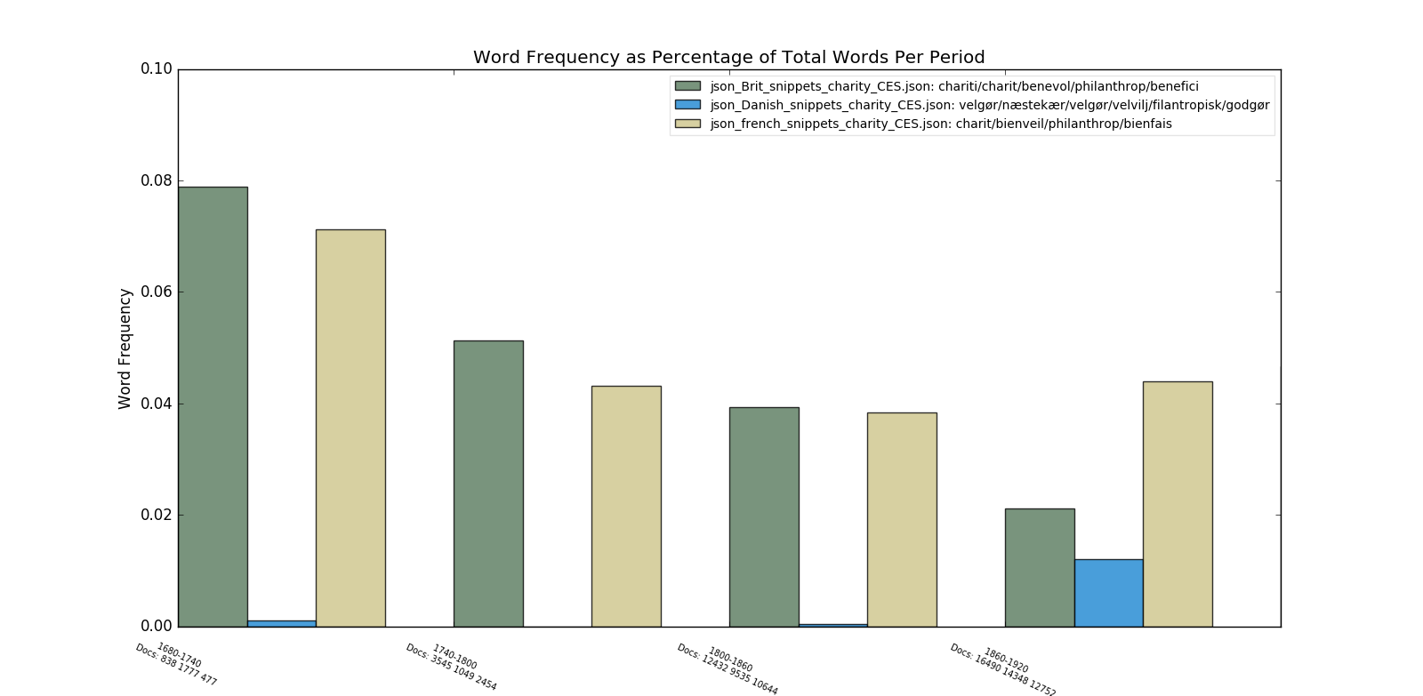

GRAPH EIGHT
FREQUENCIES OF FAMILY WORDS (WITHIN POVERTY SNIPPETS)
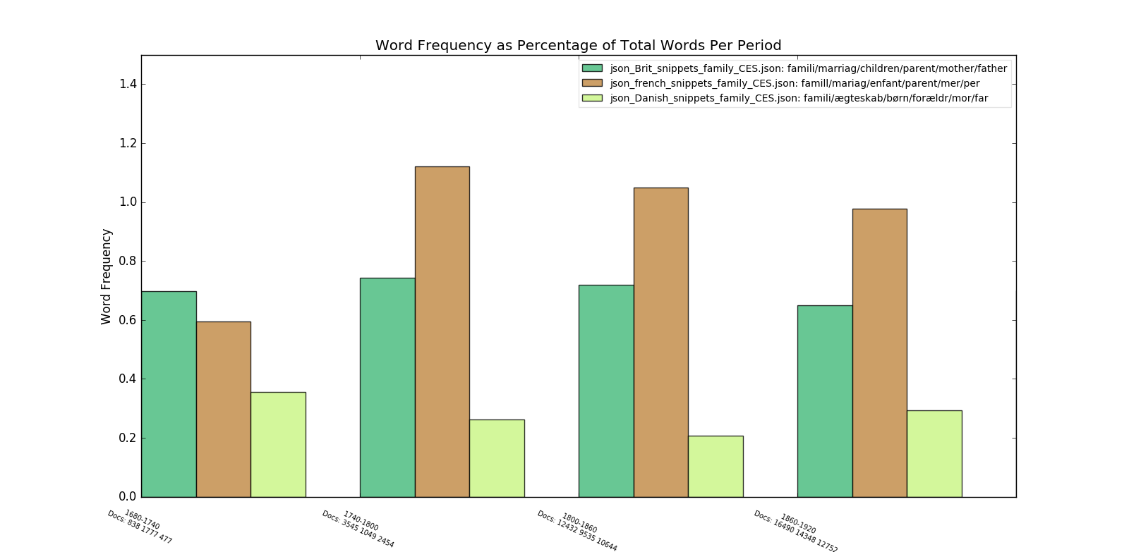

GRAPH NINE
FREQUENCIES OF RELIGION WORDS (WITHIN POVERTY SNIPPETS)
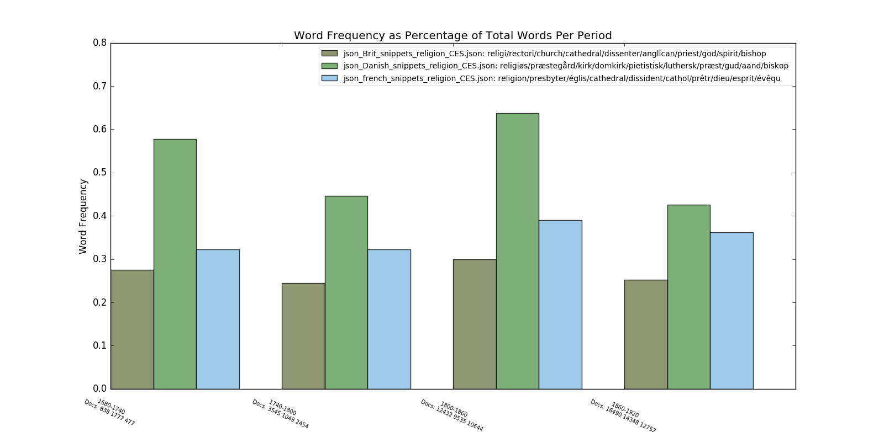

Mediterranean (Ferrera 1996) and Radical (Obinger, Leibfried, and Castles 2005) types may also exist.
Henderson, 2000, 145.
Denmark first develops social provision without the loss of civil/political rights in the revision of the Poor Law (Fattigloven) Act in 1891, which creates a public old age pension.

